cmd_vel vd cmd_vel_nav 06apr25 1025am
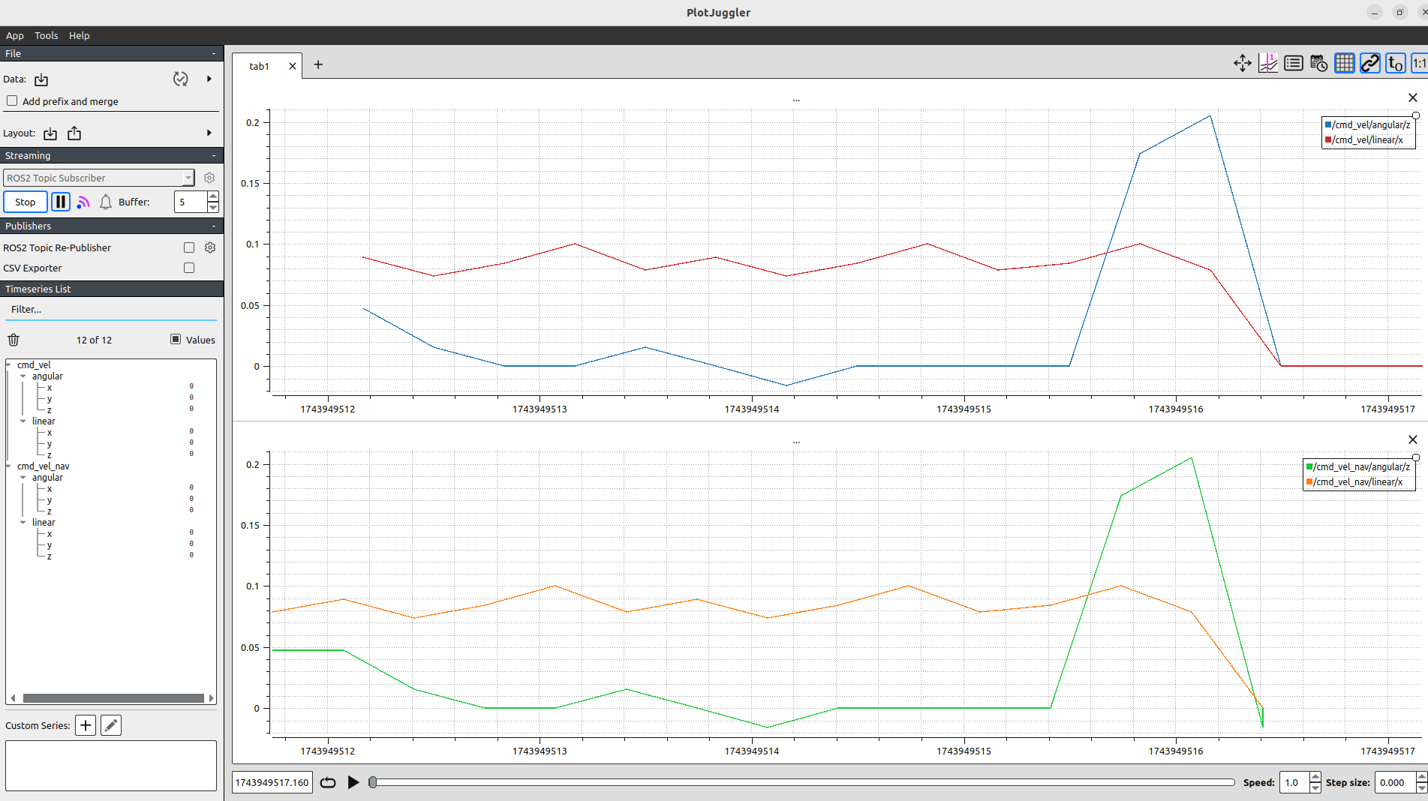
asd

1210pm controller_frequency: 20.0, smoothing_frequency: 3.0, scale_velocities: true
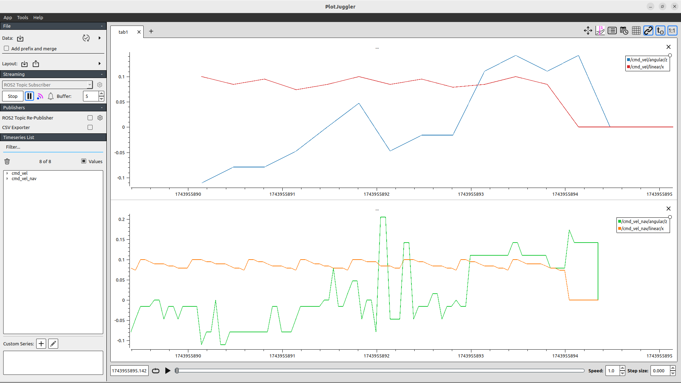

1345pm controller_frequency: 10.0, smoothing_frequency: 3.0, scale_velocities: true
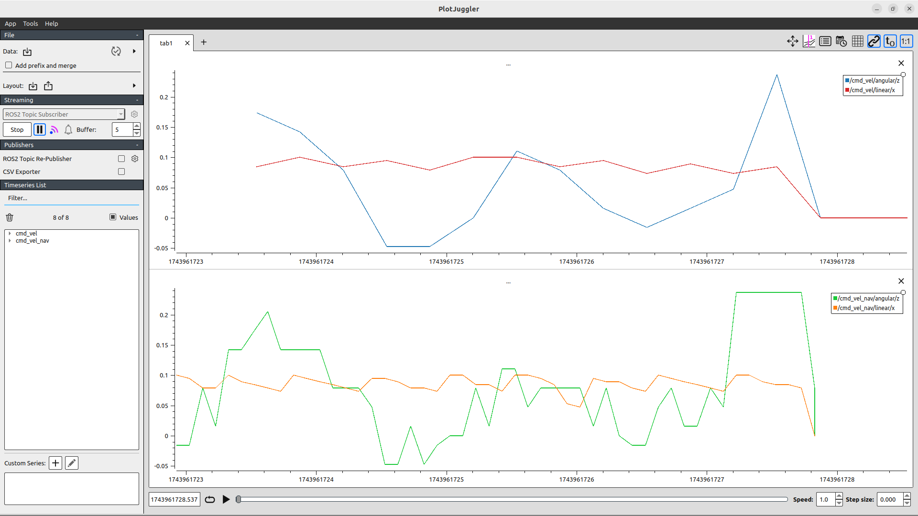
1400pm max_velocity: [0.10, 0.10, 0.3] controller_frequency: 10.0, smoothing_frequency: 3.0, scale_velocities: true

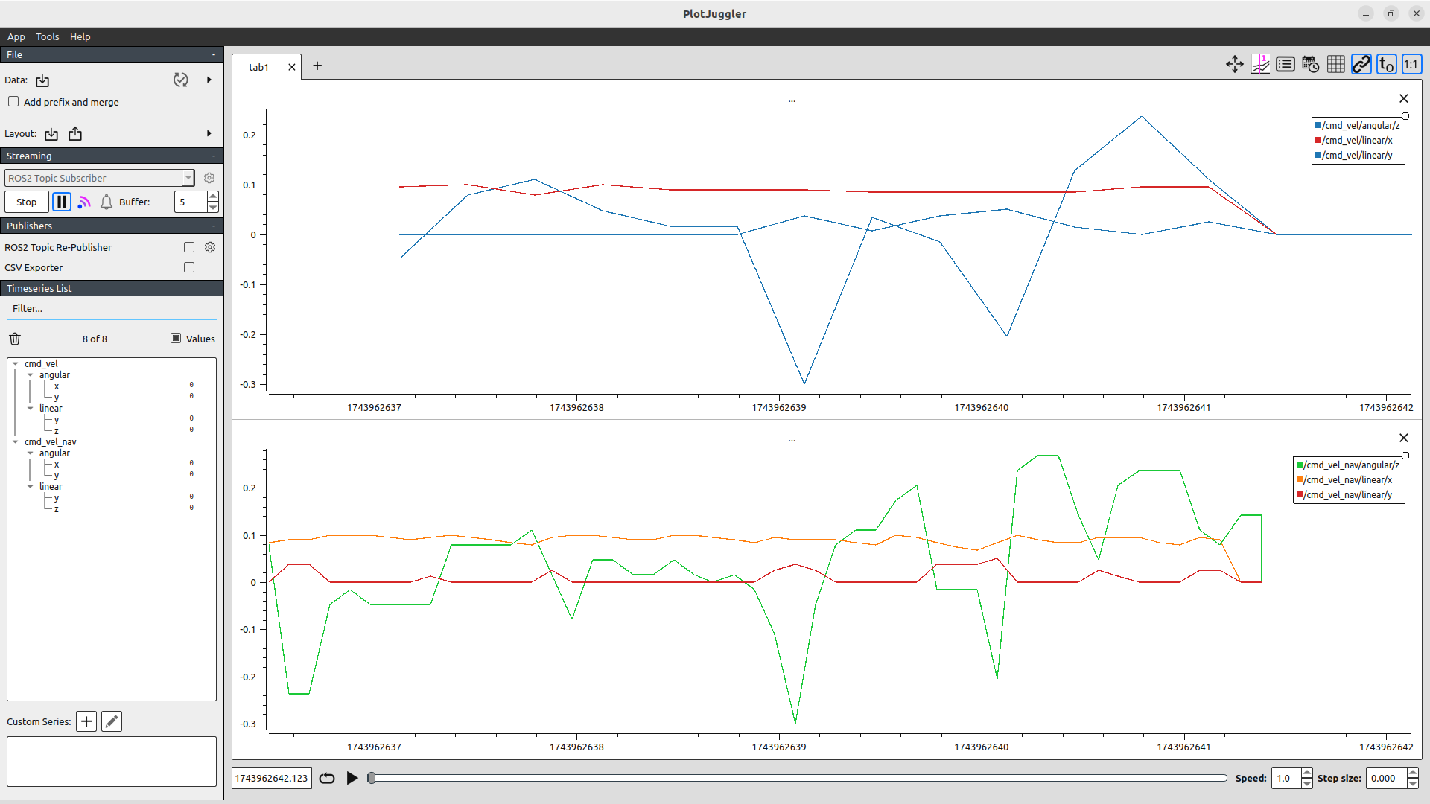
-------
4/7/25 1400pm max_velocity: [0.10, 0.0, 0.3] controller_frequency: 10.0, smoothing_frequency: 3.0, scale_velocities: true. use_astar: true. Smoothed swerve minion rotations
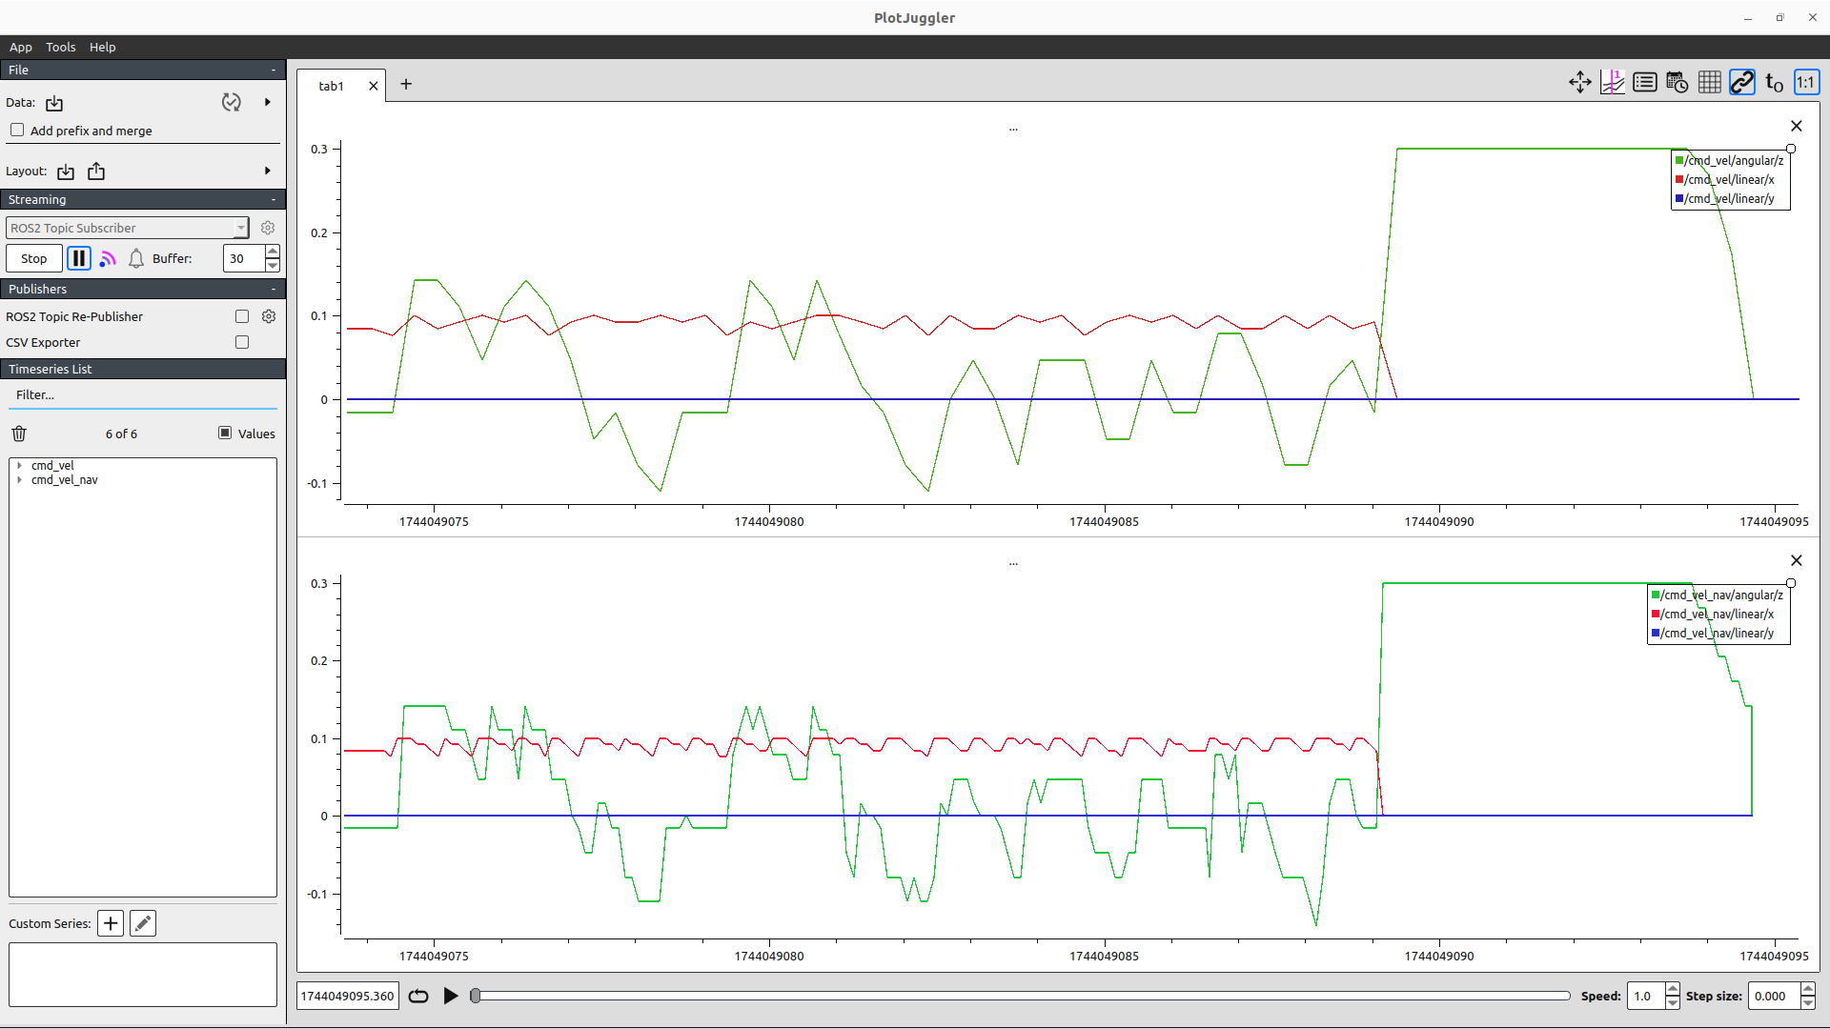
-----

4/7/25 1435pm max_velocity: [0.10, 0.0, 0.3] controller_frequency: 10.0, smoothing_frequency: 3.0, scale_velocities: true. use_astar: false. Smoothed swerve minion rotations
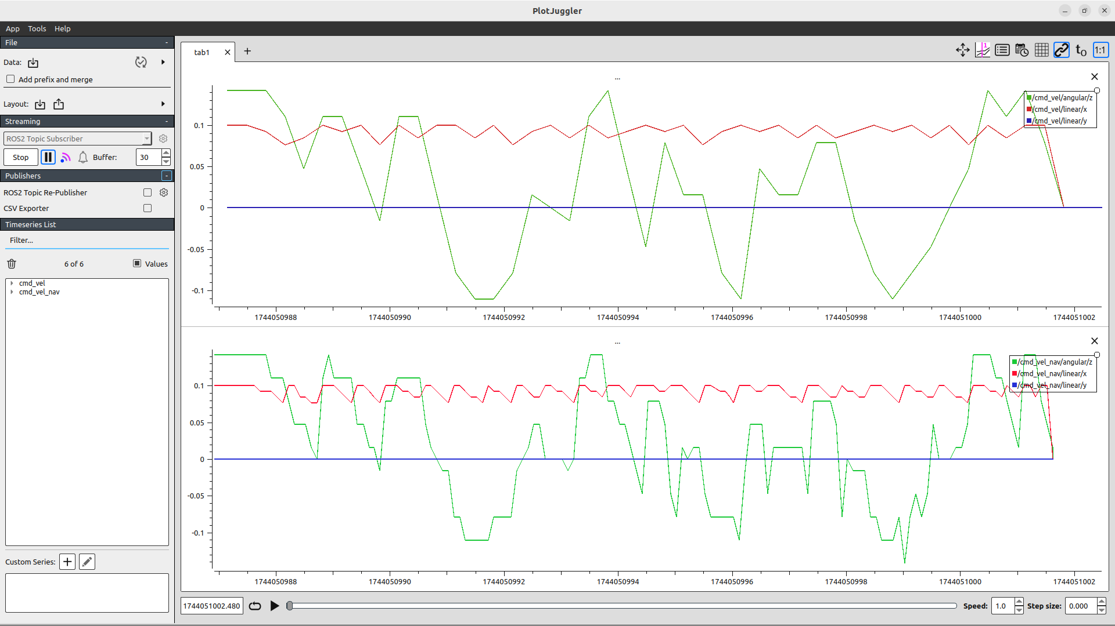
---
4/7/25 1540pm max_velocity: [0.10, 0.0, 0.3] controller_frequency: 10.0, smoothing_frequency: 10.0, scale_velocities: true. use_astar: true. Smoothed swerve minion rotations. smoother_plugins: ["simple_smoother", "savitzky_golay_smoother"]
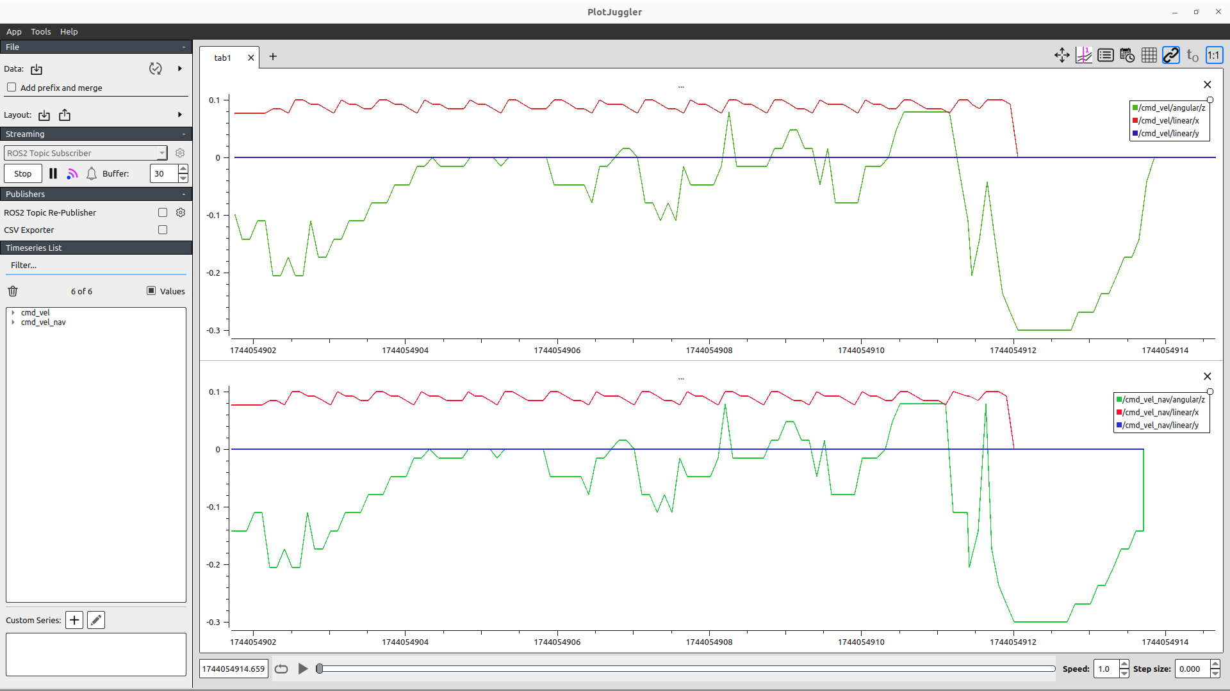
---
4/7/25 1550pm max_velocity: [0.10, 0.0, 0.3] controller_frequency: 20.0, smoothing_frequency: 20.0, scale_velocities: true. use_astar: true. Smoothed swerve minion rotations. smoother_plugins: ["simple_smoother", "savitzky_golay_smoother"]. Fast small jitters but accurate.
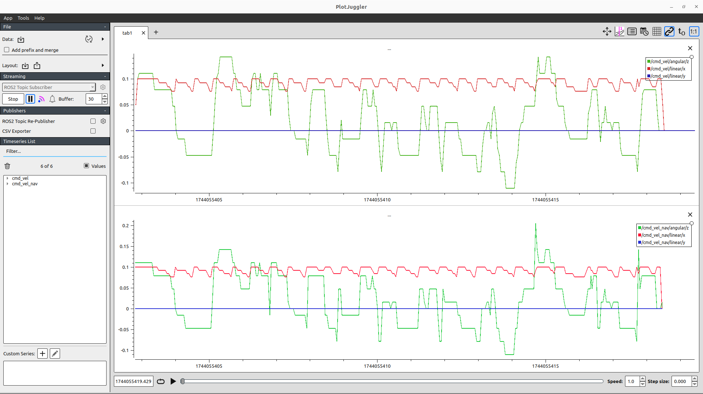
---
asd

